Tech Nation Visa — Global Talent (Exceptional Promise)
Criteria: Optional Criteria 3 — Commercial and Integration Contribution
Applicant: Odeyemi Olusegun Israel

OC3-3: SDK Distribution and Signed External Pilot Validation
1. Claim

I converted AMTTP from a closed project into externally integrable infrastructure by building TypeScript and Python SDKs, then obtained a signed and company-sealed pilot agreement for evaluation in a real business setting.
Claim | Evidence | Independent verification
SDK distribution path | TypeScript + Python packages | packages/client-sdk and packages/python-sdk
Cross-chain integration | LayerZero support across EVM networks | AMTTPCrossChain contract + SDK
External commercial validation | Signed/sealed pilot agreement | Schedule A + signature/seal exhibit
Bounded claim | Pilot evaluation, not revenue claim | agreement wording and scope

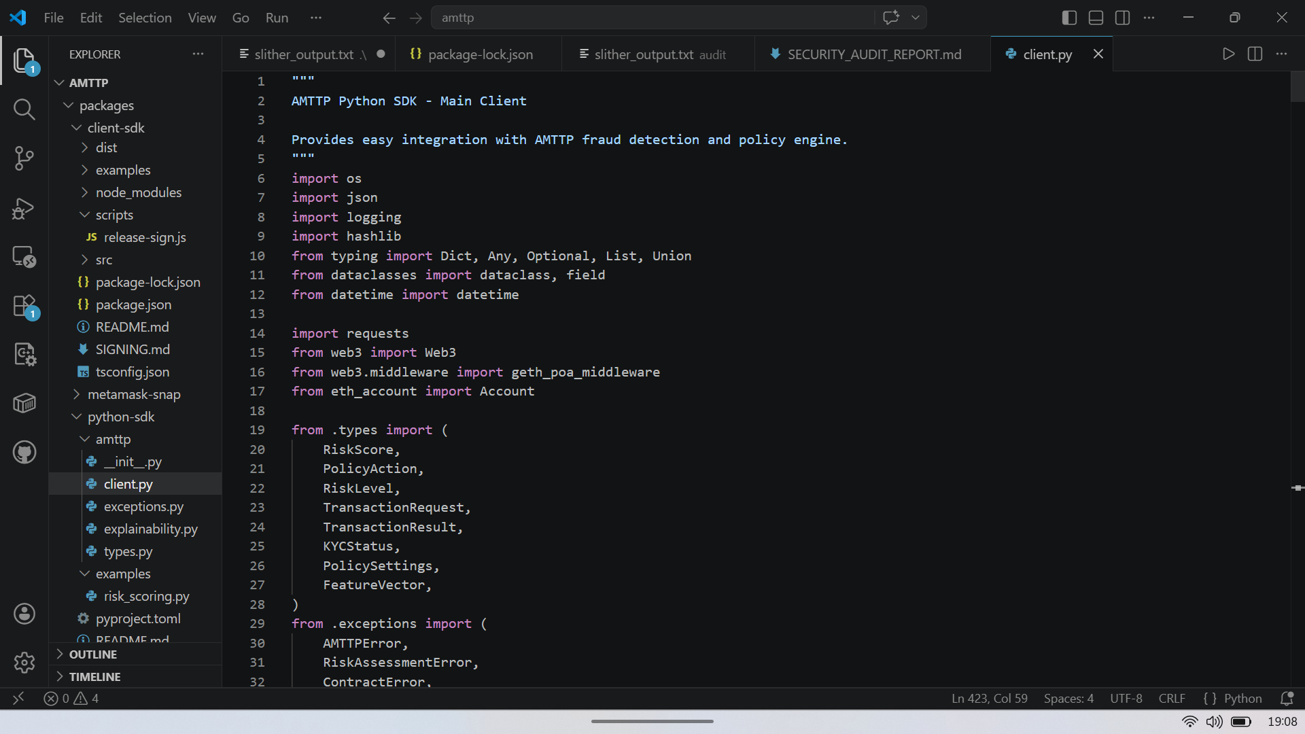
Figure 1: Two SDK packages exposing AMTTP to external integrators.
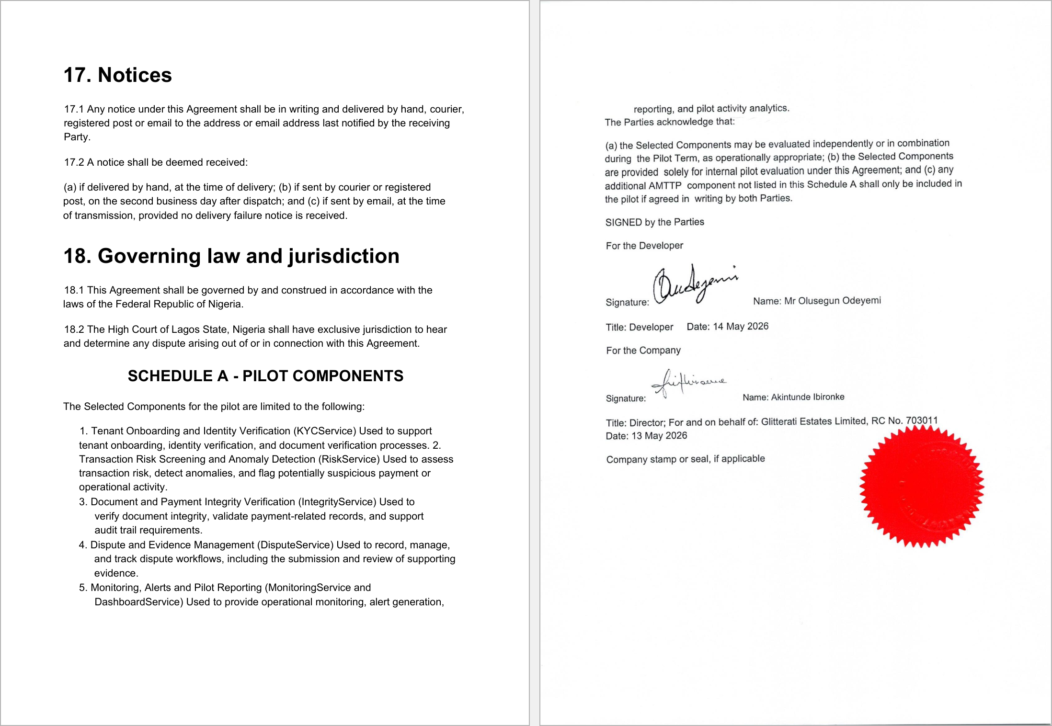
Figure 2: Schedule A pilot components and signed/sealed signature page together — external validation of evaluation scope.
Why this matters: The signed/sealed pilot is the strongest commercial evidence: an external company accepted defined AMTTP components for evaluation rather than merely viewing a demo.
Anti-loophole note: The claim is deliberately limited to independent pilot validation. It does not overclaim paid production deployment.

